

**CS251 – Software Engineering I**

Contents

Team 3

Document Purpose and Audience 3

System Models 4

System Decomposition 4

Class diagrams 5

Sequence diagrams 6

User Interface Design 8

Screen 1 – Main Screen 8

Screen 2 – Get URL Screen 8

Screen 3 – Get Package Name Screen 9

Screen 4 – Get Output Path Screen 9

Screen 5 – Generation Screen 9

Screen 6 – Alter Screen 10

Ownership Report 11

# Team

|  |  |  |  |
| --- | --- | --- | --- |
| **ID** | **Name** | **Email** | **Mobile** |
| 20120451 | Waseem Mounir Abdallah | [waseem123_73@hotmail.com](mailto:waseem123_73@hotmail.com) | 01278955766 |
| 20120500 | Kareem Hussein Bassiouni | [kareem.hussein94@yahoo.com](mailto:kareem.hussein94@yahoo.com) | 01151421688 |
| 20120454 | Yasser Adel Fares | [yasseradl54@gmail.com](mailto:yasseradl54@gmail.com) | 01000908912 |
| 20120473 | Mohammed Ahmed Tawfik | [mohamedtwfek94@yahoo.com](mailto:mohamedtwfek94@yahoo.com) | 01159701722 |

# Document Purpose and Audience

This Document include Class Diagrams, Sequence Diagrams and User Interface Design for WebService2Code Project. This document is for the system developers and system client ( SWE-1 TA ).

# System Models

## System Decomposition

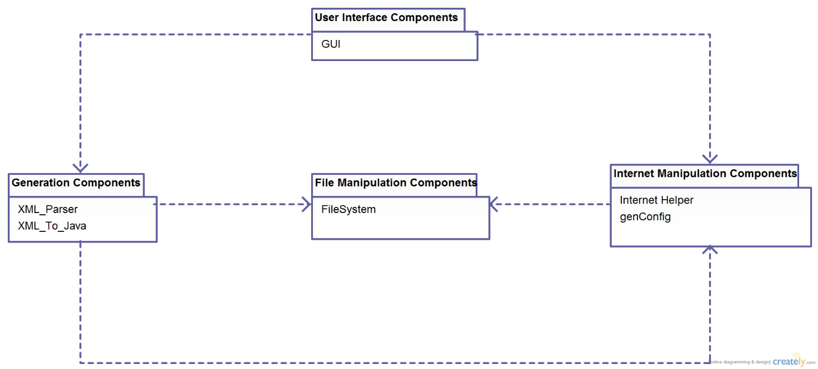

## Class diagrams

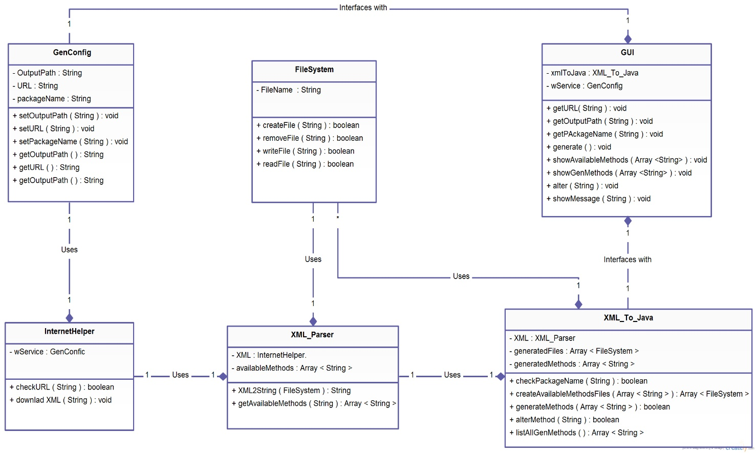

| **Class ID** | **Class Name** | **Description** |
| --- | --- | --- |
| 1 | GenConfig | Carries the information about the webservice. |
| 2 | XML_Parser | Can parse the XML document to string and get avaialable methods that can be generated. |
| 3 | XML_To_Java | Generate methods, alter methods and checks package name. |
| 3 | GUI | Makes an interface with the developer. |
| 4 | InternetHelper | Downloads WSDL and checks URL. |
| 5 | FileSystem | Creates, removes, reads and writes to files. |

## Sequence diagrams

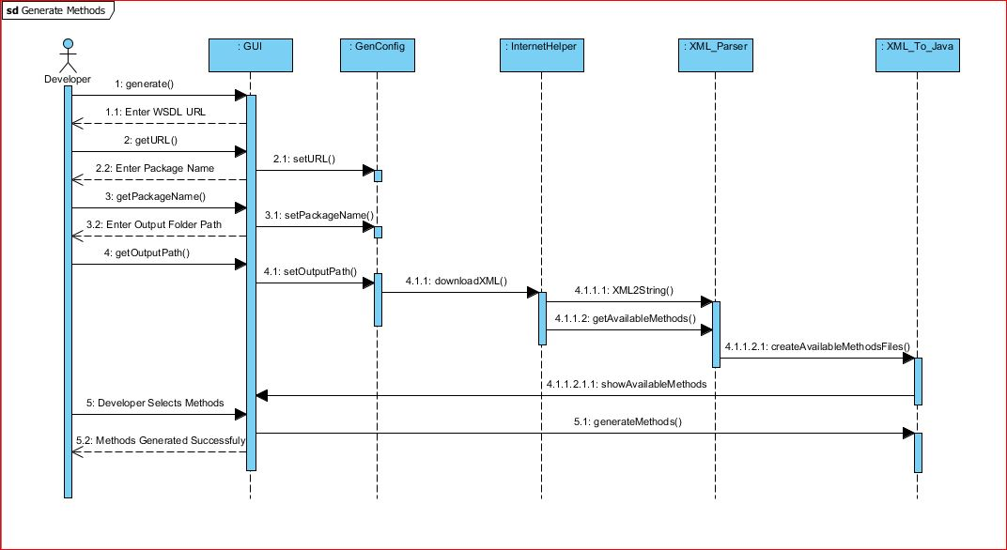

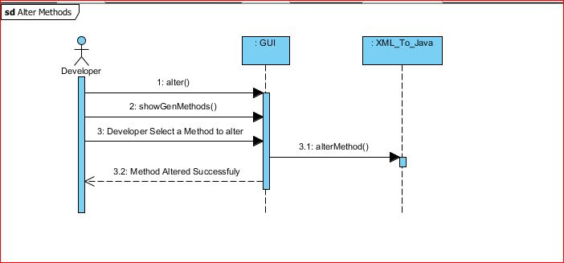

| **Class Name** | **Sequence Diagrams** | **Overall used methods** |
| --- | --- | --- |
| GUI | Generate methods & Alter methods. | alter , showGenMethod , getURL , getPackageName , getOutputPath , Generate , showAvailableMethods. |
| GenConfig | Generate methods. | setURL , setPackageName , setOutputPath. |
| XML_To_Java | Generate methods & Alter methods. | createAvailableMethods , generateMethods , alterMethod. |
| XML_Parser | Generate methods. | XML2String , getAvailableMethods. |
| InternetHelper | Generate methods. | downloadXML. |

## User Interface Design

### Screen 1 – Main Screen



* Button “Alter” : go to --> alter window
* Button “Generate” : go to -- > get URL window

### Screen 2 – Get URL Screen



* Button “Enter” : go to -- > get Package Name window
* Button “Back” : go to -- > get URL window

### Screen 3 – Get Package Name Screen

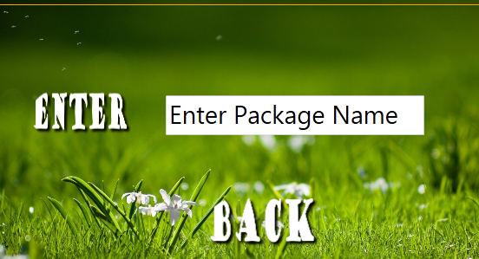

* Button “Enter” : go to -- > get Output Path window
* Button “Back” : go to -- > get Package Name window

### Screen 4 – Get Output Path Screen

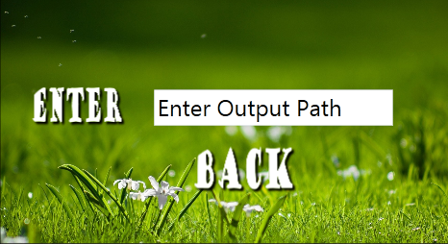

* Button “Enter” : go to -- > get Package Name window
* Button “Back” : go to -- > Generation window

### Screen 5 – Generation Screen

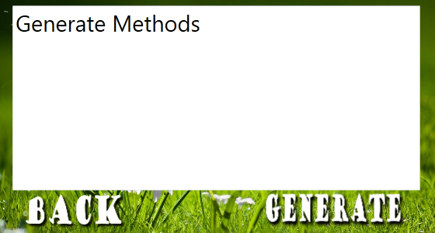

* Button “Enter” : go to -- > Main window
* Button “Back” : go to -- > get Package Name window

### Screen 6 – Alter Screen

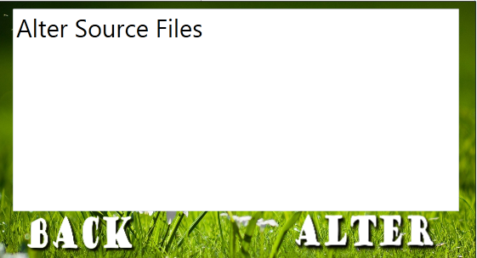

* Button “Enter” : go to -- > Main window
* Button “Back” : go to -- > Main window

# Ownership Report

|  |  |
| --- | --- |
| **Item** | **Owners** |
| System Decomposition | Kareem |
| Document Purpose , Class Diagram , Sequence Diagrams | Waseem |
| User interface Design | Kareem , Mohammed , Yasser |

# 